PROCESSES TO REDUCE PRODUCTION COSTS

- Closed Loop Rinsing

- Acid Purification

- Flux Treatment

- Circulation of Acids

Prepared by: Prepared for
Pascal Moirand, Chief Engineer AGA TECHFORUM
Siebec France Columbus, OH
October 2011
C. Tom Philipp, P.E. Revised February 1, 2012
PRO-pHx, Inc.

Introduction

The electroplating (EP) industry and the hot dip galvanizing (HDG) industry are both mature industries. The EP industry generally uses an electric current to apply a metal coating to a surface. The metals that are coated come from metal containing solutions. The HDG industry uses molten zinc to apply the coating. Both industries require the metal surfaced to be free of oils and oxides so that the final coatings will be durable and attractive.

The EP industry has been subjected to effluent limitations for many years, since many of the plating solutions contain toxic metals such as cadmium, copper, nickel, zinc and lead. To reduce the environmental impact of the EP industry, the USEPA has an active Pollution Prevention⁽¹⁾ program. The purpose of the program is to reduce the volume of water and chemicals required to produce quality products with the least harm to the environment.

Some of the proven technologies advocated by the Pollution Prevention program for the EP industry are applicable to the HDG industry. This paper will present four of these technologies that HDG plants can utilize to conserve chemicals and water that will reduce the plant’s impact on the environment, yet improve plant profitability.

Thanks are given to the AESF (American Electroplaters and Surface Finishers) Society for presentation of USEPA funded Pollution Prevention technologies and concepts.

Processes to Reduce Production Costs

Closed loop rinsing ⁽¹⁾, sometimes called Reactive Rinsing, of alkaline and acid rinse waters will minimize alkaline cleaner carry over into the acid pickle solution, which extends the life of the acid and reduces oil formation in this acid. In addition, better rinsing is accomplished by the hydraulic flow through the rinse tanks. Operating the closed loop system at approximately pH 7.0 along with effective filtration also reduces the drag-out of iron into the flux solution or the kettle.

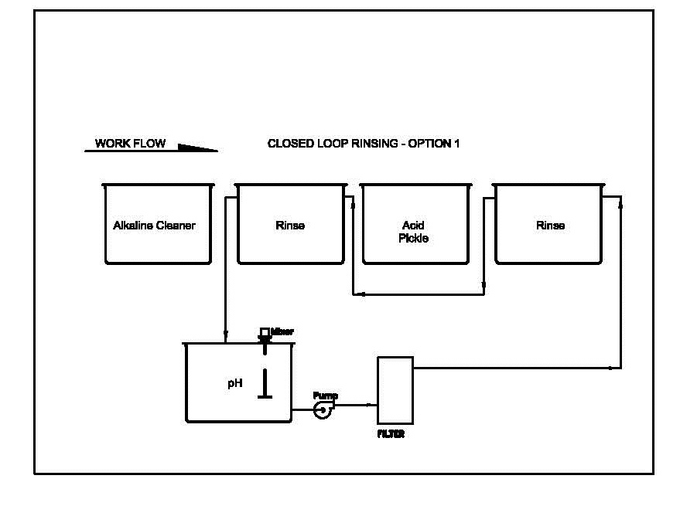

Note that poor rinsing after acid pickling allows acid and dissolved iron to be carried into the preflux tank. This practice increases dross formation in the kettle.⁽⁸⁾

The electroplating industry uses racks or barrels to process their work through alkaline cleaner tanks, acid pickle tanks and through the plating solutions. Their movement of production pieces is similar to the HDG industry. Parts are racked to promote good drainage, which reduces the rinsing requirement and helps to prevent cross contamination of process baths. For those electroplaters that do barrel work, drip times over process solutions are long enough to prevent drag-out losses downstream. The EPA has evaluated part withdrawal times and found that withdrawal rates of 15-25 ft/min along with dwell time over the process tank of 15-20 seconds will result in 90% recovery of the process solution⁽⁷⁾. The HDG industry can reduce consumption of cleaners and acids by adopting similar operating procedures.
Several chemical suppliers to the HDG industry offer acid cleaners, which can eliminate the rinse before pickling. This can reduce pickling time since some pre-pickling is accomplished by the acid cleaner. Also, this could free up the rinse tank to be converted to another acid cleaner tank or another pickle tank⁽¹⁴⁾.
A high circulation rate between the acid and alkali rinse tanks is beneficial to promote rapid and efficient rinsing. The use of a high volume low pressure pump is recommended. The following picture illustrates how suction can be taken from the alkaline rinse and pumped to the acid rinse. A bypass filter could be installed on the pump discharge or a separate pump/filter system can be installed.

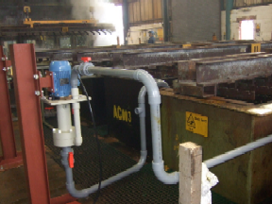

Option 2 – Acid Purification
The PRO-pHx acid purification technology was introduced to the HDG industry in 2002⁽²⁾. The chemistry, along with proper filtration, has proven to greatly extend the life of pickle acids by precipitating iron, zinc and organics. Primary savings are due to elimination of the off-site disposal costs, reduced virgin acid purchases and reduced flux treatment requirements. The technology enables the operator to stabilize the pickling process because the %acid and contaminants are stabilized. Companies report the ability to pickle at 5 – 8% HCl rather than 16%.⁽¹¹⁾

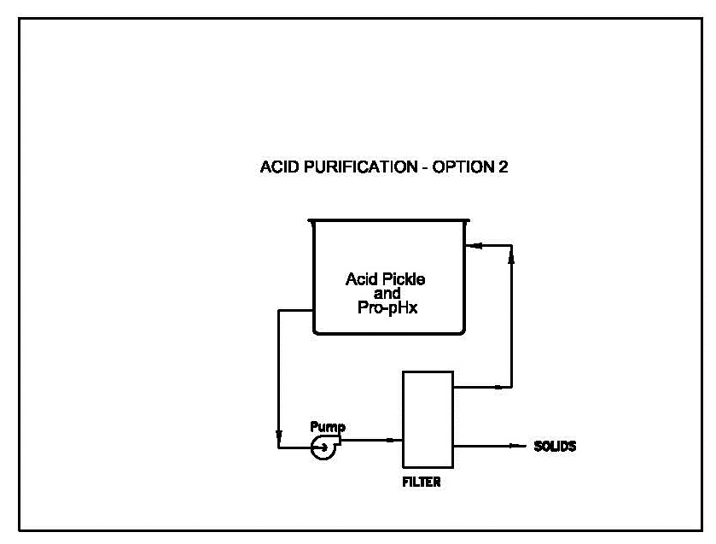

Virgin acid purchases are reduced because:
- Pickling is done at 5-8%
- Less free acid is drug into the acid rinse tank
- No free acid is hauled away
Potential profits can be projected by supplying the vendors with the following plant data:
- Number and size of pickle tanks
- Annual cost and annual volume of virgin HCL purchases
- Annual cost and annual volume of waste acid hauled or neutralized

Pickling at lower acid concentrations means less attack on the base metal, less operator exposure to acid fumes and less attack on the building structure. Some HDG plants that use sulfuric have been able to drop their operating temperatures from 160ºF to 130ºF.⁽⁷⁾
Alternatives to on-site Acid Purification
Several recycle companies will accept spent HCl pickle liquor low in zinc. The spend acid is contacted with iron shavings or iron oxide to create all ferrous chloride by the following reaction⁽⁴⁾

Fe Cl₂ + 2 HCl + Fe O → 2 Fe Cl₂ + HOH

Depending upon market conditions, the ferrous chloride can be reacted with chlorine gas to form ferric chloride, if the ferric chloride is more valuable.

2 Fe Cl₂ + Cl₂ →2 Fe Cl₃

Many municipal water or wastewater treatment plants will purchase the ferrous or ferric chloride compounds to use as coagulants.
For HDG plants that are not near recycle facilities, their options for waste acid disposal are as follows:
- Ship off-site for disposal or neutralize on-site.
- Purify, filter and reuse the acid on site.
- Install equipment to make commercial grade ferrous chloride.
- Install equipment to make commercial grade lawn fertilizer from spent sulfuric acid. ( Leggett & Platt) – ferrous ammonia sulfate⁽⁵⁾.

In Europe, hydrochloric acid is the primary acid used for pickling in the HDG industry. Because of the concentration of steel and HDG plants in the EU, especially in Germany, several companies offer thermal recycling services. The reaction is:
Fe Cl₂ + HOH + Heat →2 HCl + Fe O
The acid strength is 16% - 18% and the iron oxide byproduct has value.
Dr. Stuart Guy⁽¹³⁾ presented a report funded by the Galvanizers Association, Sutton Coldfield In October, 2003. The focus of the report was to “minimize” impurities in the spent acid and recycle the iron chloride solutions for reuse in the water treatment industry. This could be partially accomplished by using titanium for the suspension systems as a replacement for steel. The capital cost for titanium would be 5 to10 times that of steel but had a potential to increase lifetime by 5 to 20 times that of steel. Titanium is a metal that does not alloy with zinc or produce a significant surface coating.
In the U.K., the disposal for waste acids containing zinc is approximately double the cost for low zinc acids. In many cases, low zinc acids are hauled away at no charge. The author strongly recommends a separate strip tank operated at over 2% W/WHCI to generate a waste solution exceeding 200 g/l zinc. The high zinc by-product can be bled, as required, to a reactor filter. Ammonia can be used to precipitate the iron and to produce zinc ammonia chloride for use as flux.

Option 3 – Flux Treatment
It is reported that soluble iron levels in flux exceeding 0.5% will cause the formation of 100 lb. of dross for every 3 lb of iron drag-out of the flux.⁽⁶⁾ A dissolving tank, incorporated into the filter system, can be used for the addition of ammonia, hydrogen peroxide or zinc ammonia chloride. Space is minimized by the compact design and the filter cartridges are washable and reusable eliminating the cost for bag or string wound cartridges disposal plus repeat purchases.

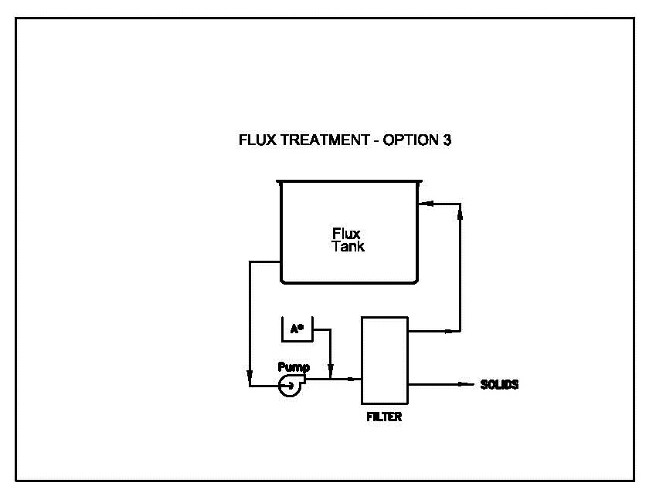

Skimmings (ash) float to the top and account for 14% of total zinc used. Generally, dross settles to the bottom of the kettle and can account for 15% of the zinc used. Messrs. Kryzwicki and Langill recommend adequate rinsing between pickling and fluxing to greatly reduce dross formation ⁽⁶⁾. In South America, it is common practice to have two rinse tanks between the pickle and flux tanks.⁽¹⁴⁾.
Management at larger and more profitable HGD plants may require continuous treatment to keep iron below 0.1%. Some plants may treat weekly and a few plants haul contaminated flux every two years at a cost of $20,000. It is estimated that 1% iron in the flux tank creates about six lbs of dross per ton of work galvanized⁽⁸⁾ Continuous filtration of the flux solution will lead to more predictable galvanizing quality. Turning over the flux tank in 1-2 hours seems desirable.
The paper by Neal Barr⁽¹²⁾presents excellent data on why pre-flux treatment is important. The variables that control pre-flux performance and, therefore, zinc coating appearance are:
- Concentration, g/l ZAC
- Temperature
- Acidity
- Zn/NH₃ balance
- Dissolved iron, g/l

Analytical procedures are given along with recommended frequency of analysis to obtain total management for maximum performance.

Option 4 – Circulation of Pickling Acids
The literature indicates a 30% increase in the pickling speed if a pump is used to circulate the acid. This is based on the Intergalva 2009 paper by Belli and Bani.⁽⁹⁾ Similar benefits can be obtained if the linear velocity of the acid is 16-24 meter/hr from one end of the tank to the other. Several “PUSH-PULL” installations in the UK have been successful but no details have been published in the literature.⁽¹⁰⁾

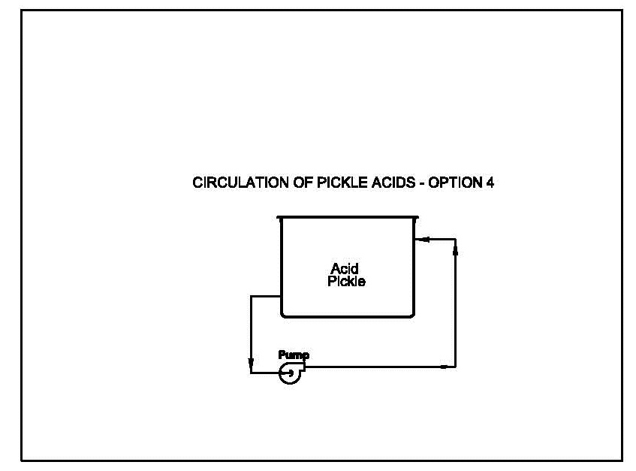
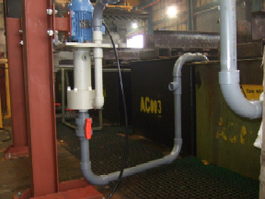

The process advantages cited in the literature include:
- Increased pickling rate
- Less concentrated pickling acid
- Lower contained volumes of acids
- Less acid requiring disposal

For plants with marginal pickling capacity and no physical room to add more pickling tanks, high rate circulation may be the most cost effective answer. Also, the use of less concentrated acids reduces virgin acid consumption and results in lower HCl emissions, which are being mandated by State and Federal authorities. Belli and Bani report a 30% savings in virgin acid consumption when the Nord Zinc Spa, Italy plant installed the Turbotank circulation system.
Now, the electroplating industry has been using circulation systems (normally incorporated with filtration) on their plating solutions for many years. The circulation improves plating quality and speed of plating and the filter removes contaminants from the plating solutions.
Due to the introduction of the PRO-pHx acid purification chemistry some 11 years ago,⁽²⁾ it is now becoming current practice to filter acid solutions. Therefore, the benefits previously mentioned due to circulation are further enhanced by simultaneous metal/organic contaminant removal.
Circulation of Pickling acids should be considered by an HDG plant that has marginal pickling capacity before expending capital dollars or euros to install additional pickling tanks. The mutual benefits of circulation and acid purification will definitely reduce production costs.
The USEPA has evaluated the preheating of parts in combination with solution agitation⁽¹⁾. The following slide provides interesting information.

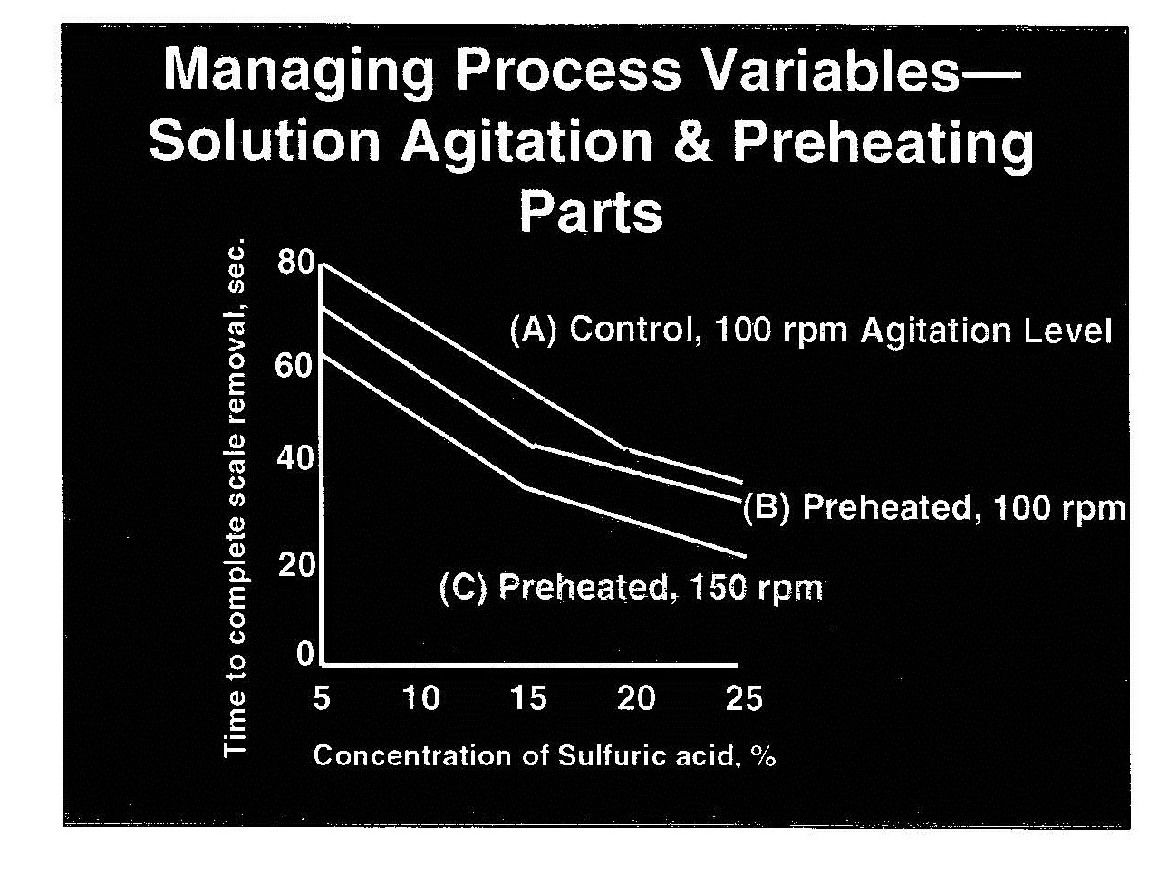
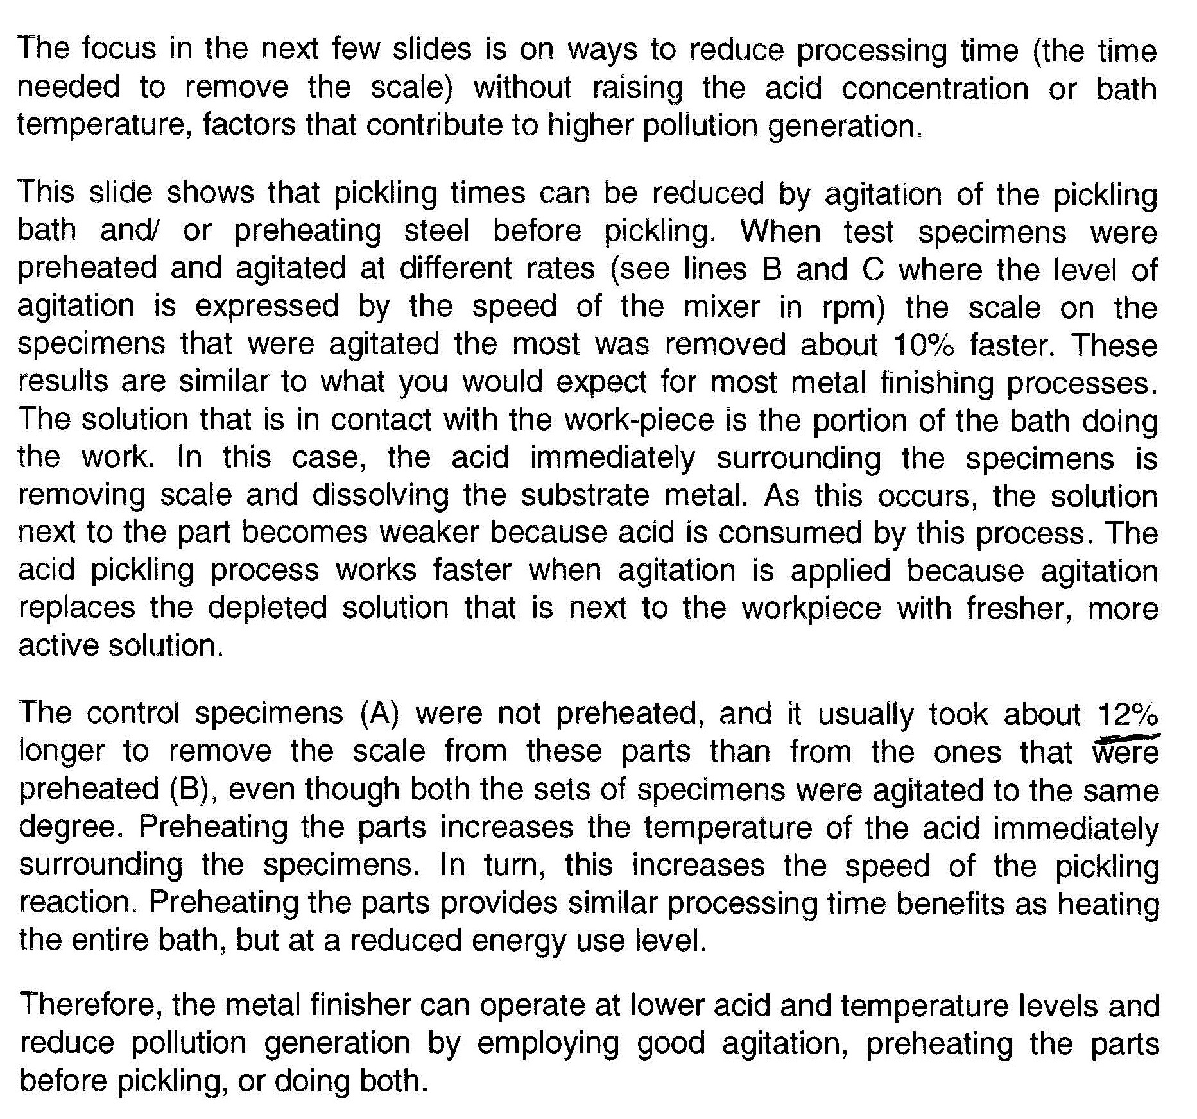
The control required 80 seconds for scale removal in 5% sulfuric when agitated at 100 rpm. Preheating the control specimen increased the scale removal by 10% at the same 100 rpm agitation. By preheating and increasing the agitation rate to 150 rpm, further increased scale removal by 12%. Increasing pickling speed by 20%-30% is possible by preheating the work (i.e., leave parts longer in the hot alkaline cleaner and a hot rinse) and using pump circulation.

CONCLUSIONS

The HDG industry is a mature industry dating back over 150 years. Back then, the galvanizer was only concerned with local competition. Now, complete galvanized parts are fabricated and galvanized in the Far East for shipment to places like Australia and the USA. Global competition is here. The galvanizing industry must adopt some of the Pollution Prevention technologies mentioned in this paper to reduce their production costs while continuing to improve galvanizing quality.
The implementation of closed-loop rinsing, acid purification, novel flux treatment or high rate circulation of acids are all proven techniques to reduce production costs. Site specific costs for virgin acid, for waste acid disposal and for electricity must be considered prior to adopting Pollution Prevention techniques and technologies.

REFERENCES FOR AGA TECHFORM PAPER

- Innovative Pollution Prevention Practices, USEPA, AESF, 1999

- Elimination of Acid Dumps, C. T. Philipp, Techforum 2004

- Acid Purification Chemistry – The Kleingarn Curve, C. T. Philipp, Techforum 2007

- Recycling Metals, Colorado School of Mines

- Private Communications, Leggett and Platt – Converting Waste Sulfuric to premium fertilizer

- Skimming and Dross, J. Krzywicki, T. Langill, 2001 AGA

- Wheatland Tube Company Study, Jim Williams – Galvanizing Foreman, April 2005

- Fluxing, G. Livelli, AGA Galvanizing Notes

- Turbotank – High Performance Agitation and Recirculation System for Pickling Baths, R. Belli, A. Berlindis Intergalva 2009, Madrid Spain

(10)Private Communication, Neal Davies, Siebec, U.K., June, 2011

(11)Private Communications, Jason Christopher, Galvcast, May, 2011

(12)Pre-flux Treatment, Why Do It, Neal Barr, 6th Annual Asia
Pacific General Galvanizing Conference, Cairns, Australia, May 2005

(13)Recycling of Spent Pickling Acid in the Galvanizing Industry, Dr. Stuart Guy,
October 2003, University of Birmingham XF CR/C002/000

(14)Private Communications, Matias del Campo, DQC, Chile, September 2011

